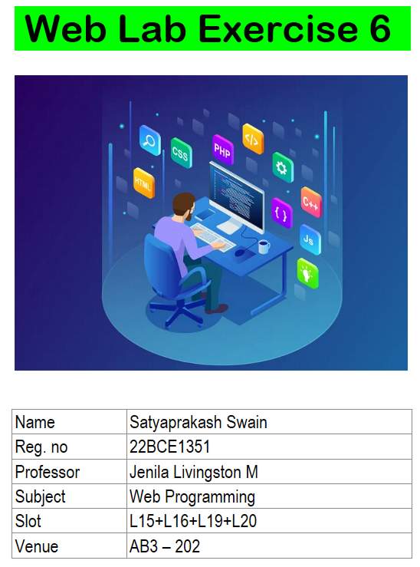

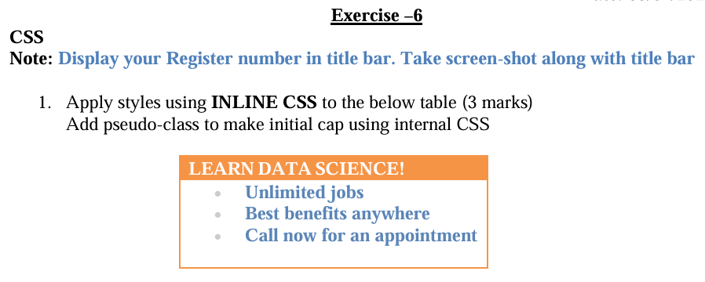

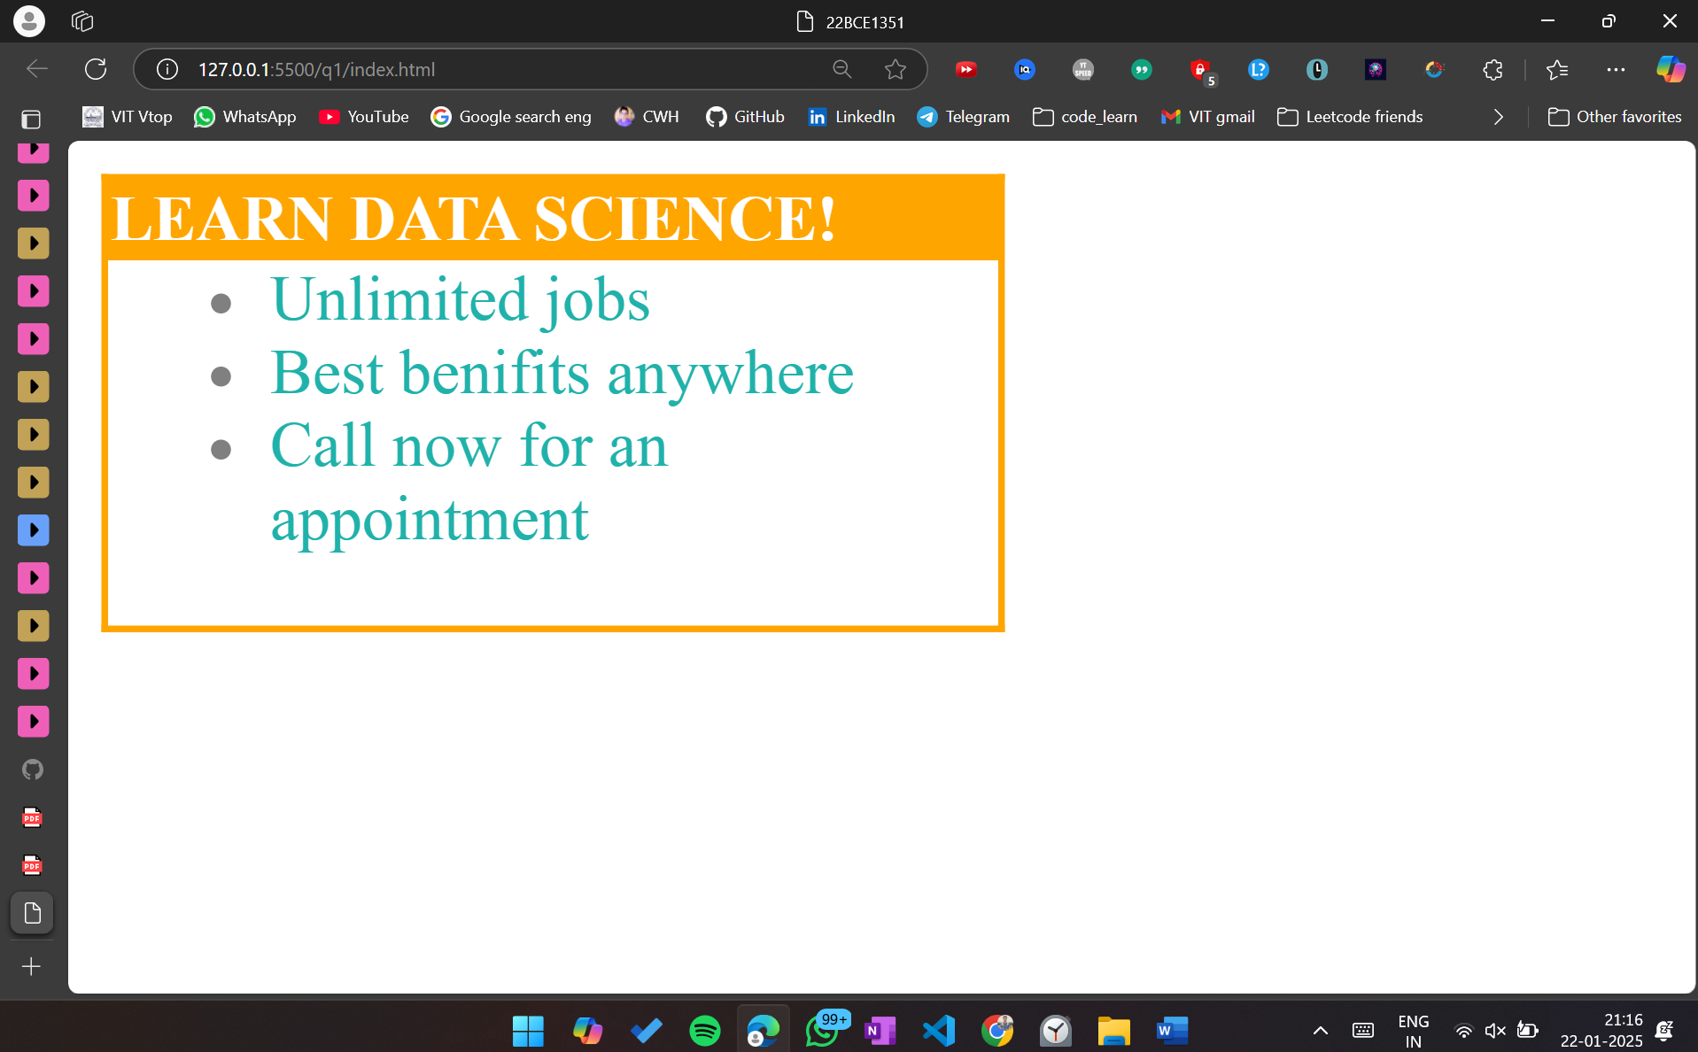

<!DOCTYPE html>

<html lang="en">

<head>

    <meta charset="UTF-8">

    <meta name="viewport" content="width=device-width, initial-scale=1.0">

    <title>22BCE1351</title>

    <style>

        li {

            color: lightseagreen;

        }

        li::marker{

            color: grey;

        }

        li::first-letter{

            text-transform: capitalize;

        }

    </style>

</head>

<body>

    <table style="border: 2px solid orange; border-collapse:collapse; width: 15%;">

        <tr>

            <td style="background-color: orange; color: white; font-weight: bold;">LEARN DATA SCIENCE!</td>

        </tr>

        <tr>

            <td>

                <ul style="margin-top: 0;">

                    <li>unlimited jobs</li>

                    <li>best benifits anywhere</li>

                    <li>call now for an appointment</li>

                </ul>

            </td>

        </tr>

    </table>

</body>

</html>

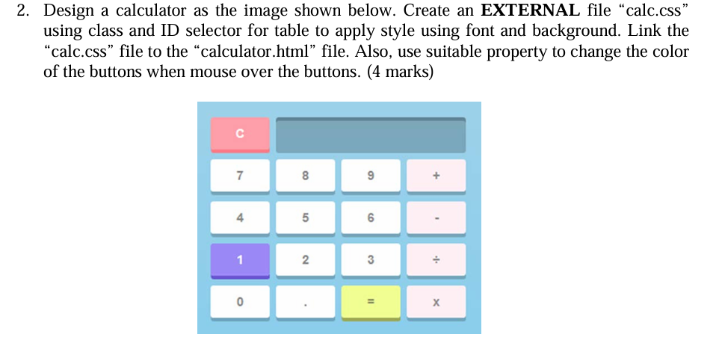

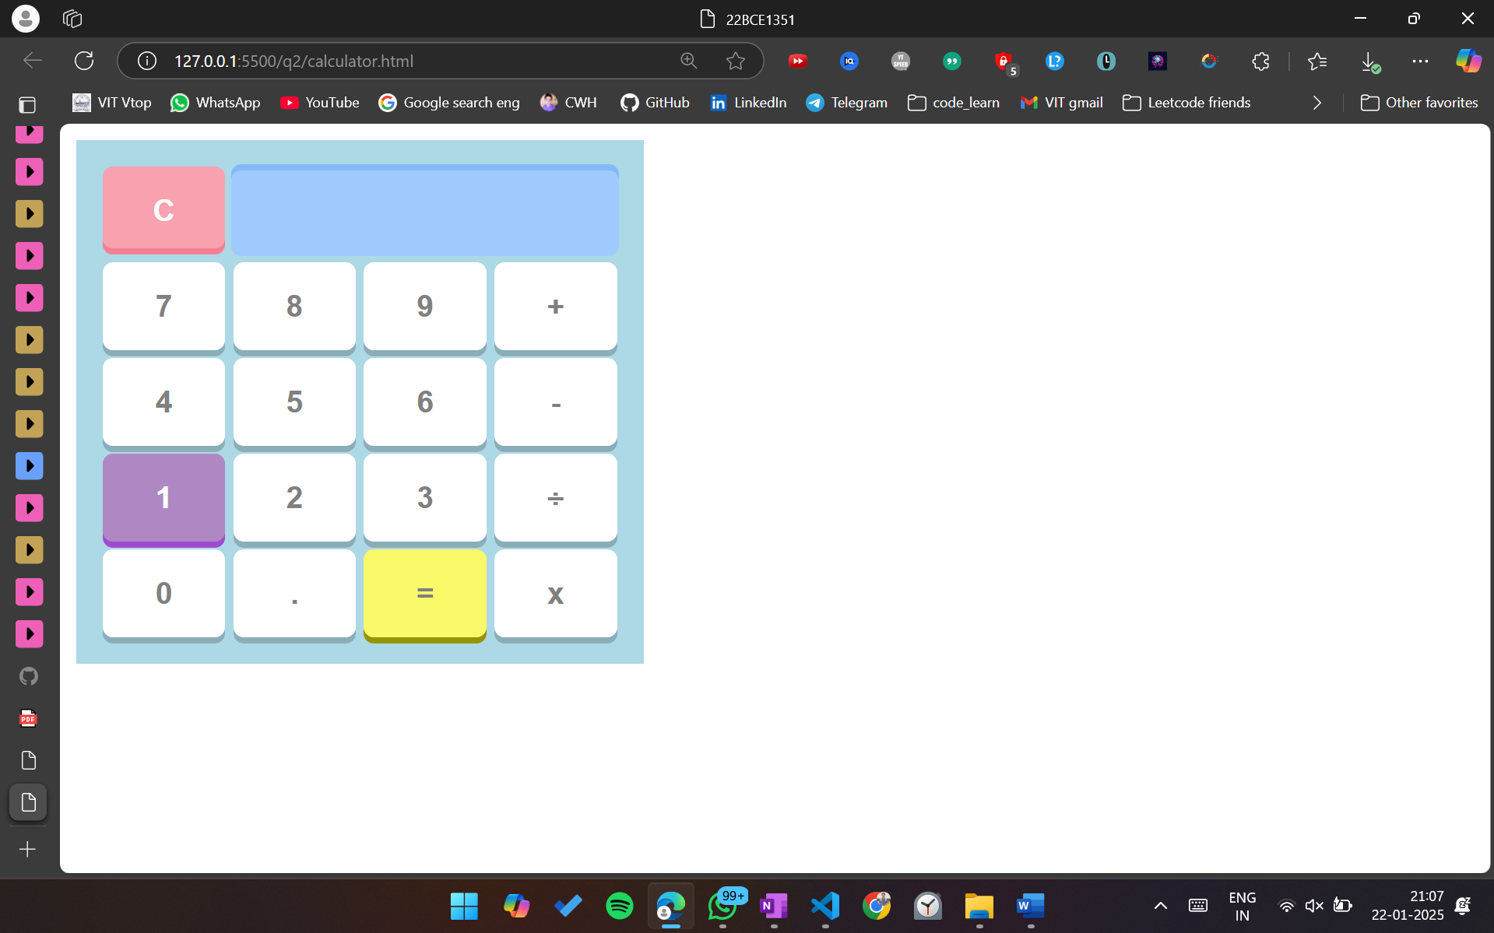

Html

<!DOCTYPE html>

<html lang="en">

<head>

    <meta charset="UTF-8">

    <meta name="viewport" content="width=device-width, initial-scale=1.0">

    <title>22BCE1351</title>

    <link rel="stylesheet" href="calc.css">

</head>

<body>

    <table class="calculator">

        <tr>

            <td colspan="1"><button class  = "button-number" id = "operator-c">C</button></td>

            <td colspan="3" id = "display"></td>

        </tr>

        <tr>

            <td><button class = "button-number">7</button></td>

            <td><button class = "button-number">8</button></td>

            <td><button class = "button-number">9</button></td>

            <td><button class = "button-number">+</button></td>

        </tr>

        <tr>

            <td><button class = "button-number">4</button></td>

            <td><button class = "button-number">5</button></td>

            <td><button class = "button-number">6</button></td>

            <td><button class = "button-number">-</button></td>

        </tr>

        <tr>

            <td><button class  = "button-number" id = "number-1">1</button></td>

            <td><button class = "button-number">2</button></td>

            <td><button class = "button-number">3</button></td>

            <td><button class = "button-number">÷</button></td>

        </tr>

        <tr>

            <td><button class = "button-number">0</button></td>

            <td><button class = "button-number">.</button></td>

            <td><button class  = "button-number" id = "operator-equal">=</button></td>

            <td><button class = "button-number">x</button></td>

        </tr>

    </table>

</body>

</html>

Css

.calculator{

    background-color: lightblue;

    padding: 10px;

    width: 250px;

}

.button-number{

    background-color: white;

    font-family:Arial, Helvetica, sans-serif;

    font-weight: 600;

    box-shadow: 0px 3px #00000033;

    border-radius: 5px;

    height: 43px;

    width: 60px;

    border: none;

    /\* margin-top: 4px;     \*/

    color: grey;

    font-size: 15px;

}

.button-number:hover{

    background-color: rgb(157, 156, 156);

    cursor:pointer;

}

#number-1{

    background-color: rgb(175, 136, 195);

    color: white;

    box-shadow: 0px 3px rgb(159, 74, 208);

}

#number-1:hover{

    background-color: rgb(136, 36, 193);

    cursor:pointer;

    box-shadow: 0px 3px rgb(131, 4, 205);

}

#operator-c{

    margin-top: 0px;

    background-color: rgb(248, 162, 176);

    color: white;

    box-shadow: inset 0px -3px rgb(244, 127, 147) !important;

}

#operator-c:hover{

    background-color: rgb(255, 127, 149);

    color: white;

    box-shadow: 0px 3px rgb(249, 82, 110);

}

#operator-equal{

    background-color: rgb(249, 249, 106);

    box-shadow: 0px 3px rgb(149, 149, 1);

}

#operator-equal:hover{

    background-color: rgb(241, 241, 73);

    box-shadow: 0px 3px rgb(133, 133, 5);

}

#display {

    background-color: #a0cafd;

    height: 40px;

    width: 200px;

    border: none;

    text-align: right;

    font-size: 18px;

    font-weight: bold;

    border-radius: 5px;

    cursor: text;

    box-shadow: inset 0px 3px #84b9f9;

}

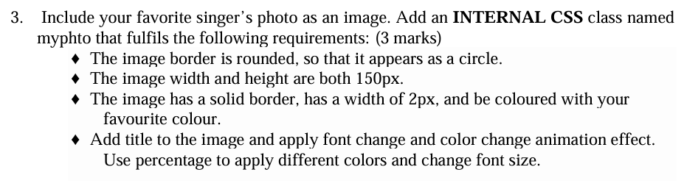



Html (inline css)

<!DOCTYPE html>

<html lang="en">

<head>

    <meta charset="UTF-8">

    <meta name="viewport" content="width=device-width, initial-scale=1.0">

    <title>Favorite Singer 22BCE1351</title>

    <style>

        .myphto {

            width: 150px; /\* Set image width \*/

            height: 150px; /\* Set image height \*/

            border-radius: 50%; /\* Makes the border rounded to create a circle \*/

            border: 2px solid #ff4500; /\* Solid orange border \*/

            display: block;

            margin: 0 auto; /\* Center the image \*/

        }

        figcaption {

            text-align: center;

            font-size: 16px;

            font-weight: bold;

            margin-top: 10px;

            animation: changeFont 4s infinite;

        }

        @keyframes changeFont {

            0% {

                color: #ff4500;

                font-size: 16px;

            }

            50% {

                color: #1e90ff;

                font-size: 18px;

            }

            100% {

                color: #32cd32;

                font-size: 16px;

            }

        }

    </style>

</head>

<body>

    <figure>

        <img class="myphto" src="KK.jpg" alt="Favorite Singer">

        <figcaption>Fig. 1. Favorite Singer</figcaption>

    </figure>

</body>

</html>

